MOBILE PHONE - STORE MANAGEMENT SYSTEM

Software Requirements Specification
Version 4.0

Danang, Feb 2015

TABLE OF CONTENTS
TABLE OF CONTENTS 2
1. DOCUMENT HISTORY 3
2. REFERENCE DOCUMENTS 3
3. DISTRIBUTION LIST AND APPROVALS 3
4. INTRODUCTION 3
4.1 Purpose 3
4.2 In Scope 4
5. OVERVIEW 4
5.1 Actors 4
5.2 System Use Case Diagram 5
5.3 System Pages Flow 9
6. Functional Description 10
6.1 User interface: 10
6.2 Phones Management: 13
6.3 Assets Management: 25
6.4 Staff Management 36
6.5 Report 42
7. NON-FUNCTIONAL REQUIREMENTS AND OTHERS 46
Performance 46
Scalability 46
Security 46
Network 46
Backup and restore 46
Reliability 47
Interfaces 47
User manual and help 47
Extensibility 47
8. APPENDIX 47

DOCUMENT HISTORY
Date | Summary of Changes | Version
22/1/2015 | Release the first version of the SRS document | 1.0
29/1/2015 | These changes followed the comments of stakeholder (i.e. reviewer AnNPT):  - System’s Purpose and Non-Functional Requirements by Binh Pham.  - Overview (diagrams: admin roles and user roles) by Cung Vo.  - Functional Description by Dung Pham.  - Synthesis and Editing by Chanh Le (team leader). | 2.0
5/2/2015 | These changes followed the comments of stakeholder  - Overview (diagrams: admin roles and user roles) by Cung Vo and Chanh Le.  - Functional Description by Dung Pham and Binh Pham. | 3.0
12/2/2015 | These changes followed the comments of stakeholder  - Overview (diagrams: admin roles and user roles) by Cung Vo and Chanh Le.  - Functional Description by Dung Pham and Binh Pham. | 4.0

REFERENCE DOCUMENTS
Document Name | Description
Software Requirements Specification Order Room Management System | ORMS_SRS_v1.2_EN.docx  Dot Net Team – FPT software
Object Oriented Analysis and Design | Slides  A. Prof. Dr. Nguyen Thanh Binh – IT Faculty, DUT
Software Engineering | Slides  A. Prof. Dr. Nguyen Thanh Binh – IT Faculty, DUT

DISTRIBUTION LIST AND APPROVALS
This document is distributed to the following stakeholders to get their valuable comments and corrections.
Name | Title

INTRODUCTION

Purpose
- This project, Mobile phone store management system is a software allow manager to manage a mobile phone store, to keep staff and every selling activities under control, by this way, he is aware the status of his store, he could manage his budget and come up with a strategy business in order to get a maximum value from that.

In Scope
- The scope pertains to the Mobile Phone - Store Management. It focuses on the store, products, staffs, selling activities, delivering and applications, which allow for online sales, distribution and marketing.
- This SRS is also aimed at specifying requirements of software to be developed but it can also be applied to assist in the selection of in-house and commercial software products. The standard can be used to create software requirements specifications directly or can be used as a model for defining an organization or project specific standard. It does not identify any specific method, nomenclature or tool for preparing an SRS.

OVERVIEW

Actors
The below diagram describes all actors of the Mobile Phone - Store Management System. An actor represents a User Role; currently we have Administrator and Normal User Account. Each user has his actions when accessing into the system.

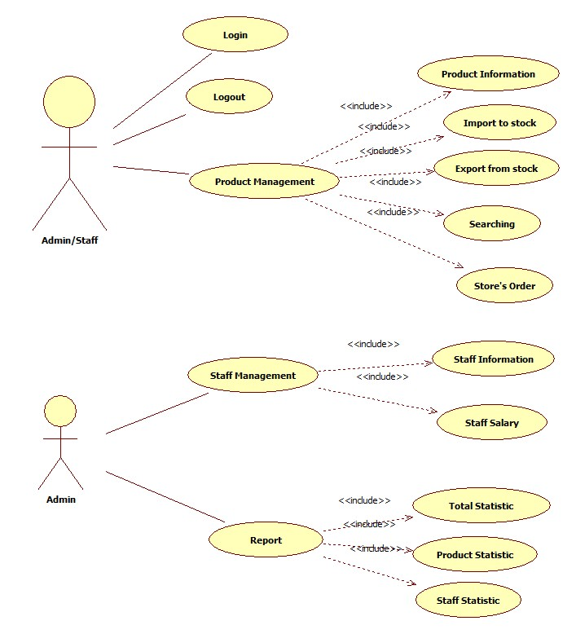
Actor | Description
Administrator | Has the right to View, Add new, Update and Delete data in all modules.
Normal User Account | Has the right to View, Add new, Update and Delete data in all modules, except User Accounts Maintenance and Report.

System Use Case Diagram
The following diagram provides an overall picture of the functionality groups, Actors of the Mobile Phone - Store Management System. Mobile Phone - Store Management System’s functionalities are divided into these use cases:

Product Management

Product Information
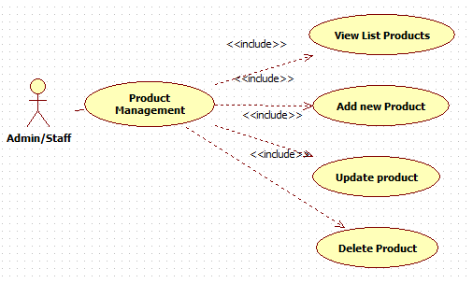

Import to stock
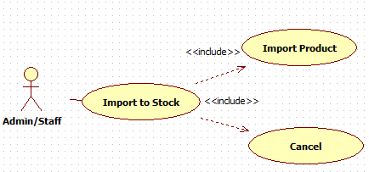

Export from stock
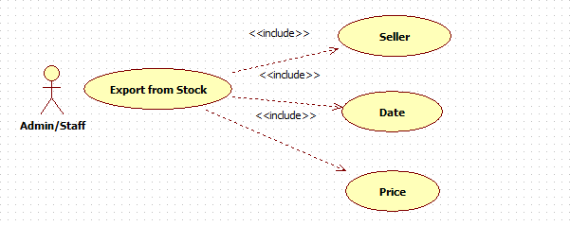

Store’s order
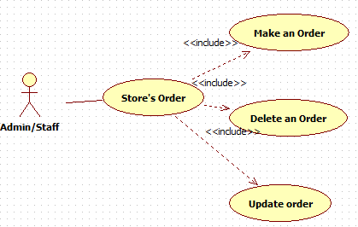

Searching
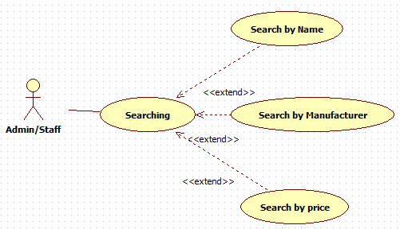

Staff Management

Staff Information
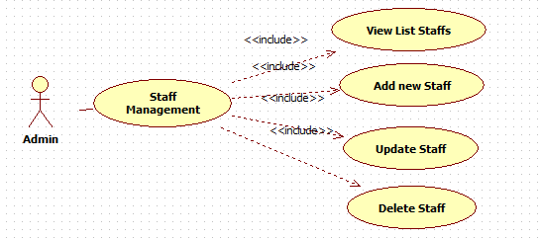

Staff Salary
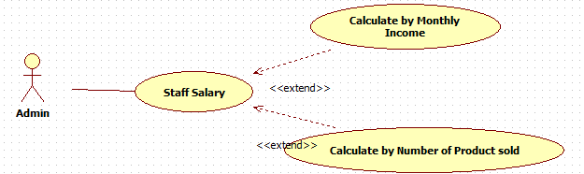

Report
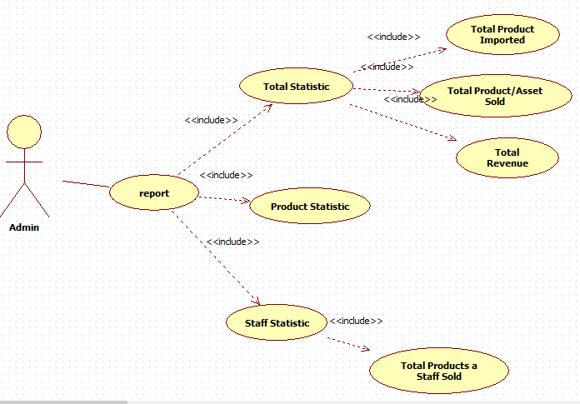

System Pages Flow
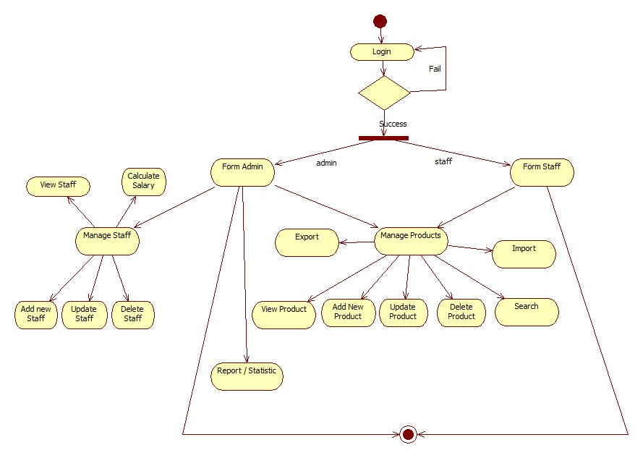

Functional Description

User interface:
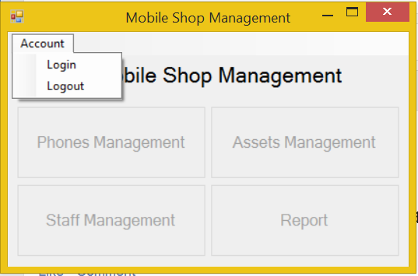
Screen | Mobile Shop Management – User interface
Description | Display a screen where user can control the product.
Screen Access | Users run program by click on file MobileShopManagement.exe
Screen Content
Item | Type | Data | Description
Mobile Shop Management | Label |  | Name of the software
Account | Menu strip item |  | Name of menu strip
Log in | Menu strip item |  | Open a dialog where user can log into program
Log out | Menu strip item |  | Log out the program.
Phones Management | Button |  | If user click on this button, the “Phones Management” dialog will appear.
Assets Management | Button |  | If user click on this button, the “Assets Management” dialog will appear.
Staff Management | Button |  | If user click on this button, the “Staff Management” dialog will appear.
Report | Button |  | If user click on this button, the “Report” dialog will appear.
Screen Actions
Action Name | Description |  | Success | Failure
Log in | Everyone have an account and click on it to enter the system. |  | Login dialog opened. | Nothing.
Log out | Use to exit the system. |  | Username of current user at the bottom of screen will be disappeared and all button will be disabled. | Nothing.
Phones Management | Go to Phones Management function. |  | “Phones Management” dialog opened | If the program cannot connect to the database, display a message: “Database connection error.”  If there’re any coding exceptions when running this function, a message will be appeared: “Cannot open ‘Phones Management’ dialog”.
Assets Management | Go to Assets Management function. |  | “Assets Management” dialog opened | If the program cannot connect to the database, display a message: “Database connection error.”  If there’re any coding exceptions when running this function, a message will be appeared: “Cannot open ‘Assets Management’ dialog”.
Staff Management | Go to Staff Management function. |  | “Staff Management” dialog opened | If the program cannot connect to the database, display a message: “Database connection error.”  If there’re any coding exceptions when running this function, a message will be appeared: “Cannot open ‘Staff Management’ dialog”.
Report | Go to Report function. |  | “Report” dialog opened | If the program cannot connect to the database, display a message: “Database connection error.”  If there’re any coding exceptions when running this function, a message will be appeared: “Cannot open ‘Report’ dialog”.

User interface – Login
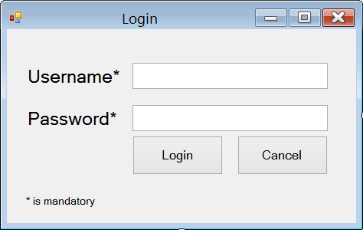
Screen | User interface - Login
Description | Display a screen where user can login to the system.
Screen Access | Users run program then click on Account -> Login
Screen Content
Item | Type | Data | Description
Username | Text field – String (50) |  | This field is mandatory. Name of user’s account.
Password | Text field – String (50) |  | This field is mandatory. Password of user’s account.
* is mandatory | Label – String (50) |  | A note for mandatory field.
Login | Button |  | User click on this button to login to the system.
Cancel | Button |  | User click on this button to cancel the login session.
Screen Actions
Action Name | Description |  | Success | Failure
Log in | User click on it to login. |  | Login form disappeared and username of current user will display at the bottom of screen and all buttons will be enabled. | If username or password does not match the database, a message appeared: “Username or password is incorrect.”
Cancel | Use to exit the login dialog. |  | Login form disappeared and all button on main form will still be disabled. | Nothing.

Phones Management:
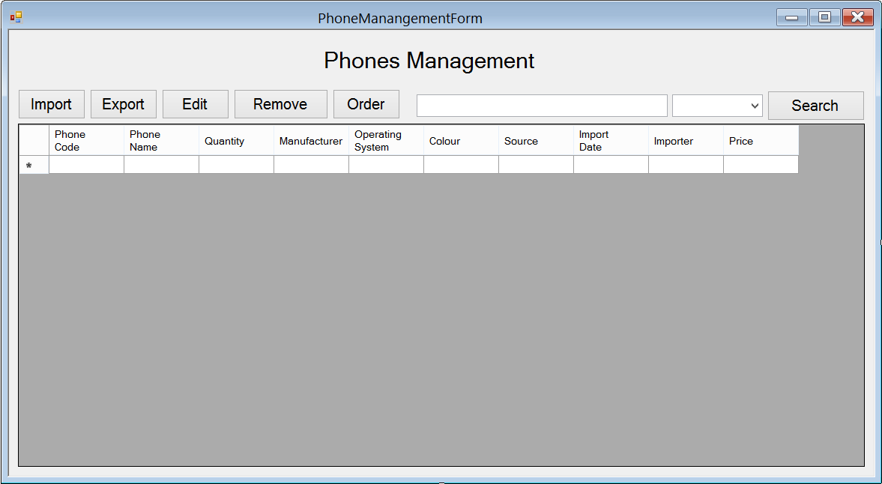
Screen | Phones Management
Description |  | Show information of phones, user can import new phones, export (sell) them, edit their information, remove them. In case they run out of some phones, they could order some more.
Screen Access |  | Users run program then click on Phones Management button
Screen Content
Item |  | Type | Data | Description
Data grid view |  | Data grid view | Lookup all fields from PHONE table. | - Display all fields about the phone when the form loaded: phone code, phone name, quantity, manufacturer, operating system, colour, source, import date, importer, price, location.  - This table is read-only, user cannot edit it.
Import |  | Button |  | User click on it to open “Import Phones” dialog and add new phones.
Export |  | Button |  | User click on it to open “Export Phones” dialog and add information of selling phone into database.
Edit |  | Button |  | User click on it to open “Edit Phones” and edit information of phone
Remove |  | Button |  | User click on it to remove the chosen phones in data grid view in case they stop selling them.
Order |  | Button |  | Open “Order Phones” dialog. When the store run out of some phones or some new phones that they don’t have, they could order their distributor to get them.
Search |  | Button |  | Search phones by name, manufacturer, price
Textbox |  | Text field – String (50) |  | Enter the keyword that user want to search.
Combo box |  | Drop down list |  | User choose which field they want to search by: name, manufacturer and price.
Screen Actions
Action Name |  | Description |  | Success | Failure
Import |  | Add information of new phones. |  | “Import Phones” dialog opened. | If there’re any coding exceptions when running this function, a message will be appeared: “Cannot open ‘Import Phones’ dialog”.
Export |  | Add information of selling phones. |  | “Export Phones” dialog opened. | If there’re any coding exceptions when running this function, a message will be appeared: “Cannot open ‘Export Phones’ dialog”.
Edit |  | Edit information of phones. |  | “Edit Phones” dialog opened. | If the program cannot connect to the database to get the Phone’s information, display a message “Database connection error”.  If there’re any coding exceptions when running this function, a message will be appeared: “Cannot open ‘Edit Phones’ dialog”.
Remove |  | Remove phones from database. |  | Data grid view’s item removed. | Nothing.
Order |  | Make an order for new phones. |  | “Order Phones” dialog opened. | If there’re any coding exceptions when running this function, a message will be appeared: “Cannot open ‘Order Phones’ dialog”.
Search |  | Find a phone in the table below. |  | Return the result of searching process. | If there aren’t anything match with the input keyword, display a message: “Not found”.

Phones Management – Import
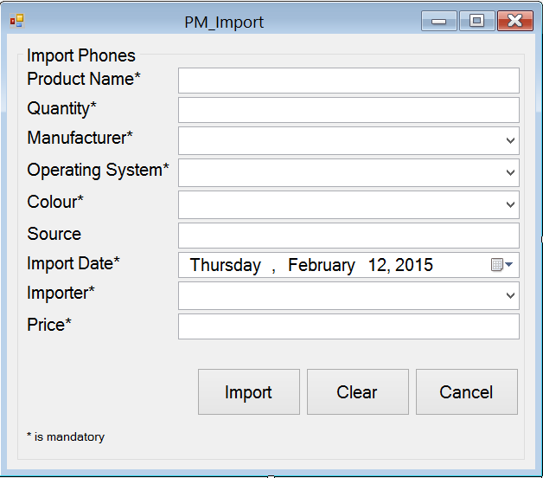
Screen | Phones Management - Import
Description | Add new phone into data base
Screen Access | Users run program by click on file Phones Management -> Import
Screen Content
Item | Type | Data | Description
Import Phone | String (50) | Hard code | A title label.
Phone Name | Text field – String (50) | Inserted into PHONE.NAME | This field is mandatory. The name of phone.
Quantity | Text field – String (50) | Inserted into PRODUCT.QUANTITY | This field is mandatory and number-only. The quantity of phone
Manufacturer | Dropdown list – String (50) | Lookup from table MANUFACTURER.NAME then input into PHONE.MANUFACTURER | This field is mandatory. The name of the manufacturer.
Operating System | Dropdown list – String (50) | Lookup from table OPERATINGSYSTEM.NAME then input into PHONE.OPERATINGSYSTEM | This field is mandatory. The name of the Operating System
Colour | Dropdown list – String (50) | Lookup from table COLOR.NAME then input into PHONE.COLOR | This field is mandatory. The colour of Phone
Source | Text field – String (50) | Inserted into PHONE.SOURCE | Where the phone has been made.
Import Date | Date time picker | Inserted into PHONE.IMPORTDATE | This field is mandatory. When the phone was imported.
Importer | Dropdown list – String (50) | Lookup from table STAFF.NAME then input into PHONE.STAFF | This field is mandatory. Who import the phone.
Price | Text field – String (50) | Inserted into PHONE.PRICE | This field is mandatory and number-only. The price of the phone
* is mandatory | Label – String (50) |  | A note for mandatory field.
Import | Button |  | Import new phone
Clear | Button |  | Clear all the fields
Cancel | Button |  | Cancel importing action
Screen Actions
Action Name | Description |  | Success | Failure
Import | Import new phone |  | Show a message to ask for confirmation.  Show message: “[Quantity] phone(s) has been imported”. | If the program cannot connect to the database, display a message: “Database connection error.”  If user doesn’t enter the phone’s name, display a message:  “Phone name must be entered.”  If user doesn’t enter the quantity display a message: “Quantity must be entered.”  If user doesn’t choose the manufacturer’s name, display a message: “Manufacturer must be chosen.”  If user doesn’t choose the operating system, display a message: “Operating system must be chosen.”  If user doesn’t choose the phone’s colour, display a message: “Colour must be chosen.”  If user doesn’t choose the import date, display a message: “Import date must be chosen.”  If user doesn’t choose the importer, display a message: “Importer must be chosen.”  If user doesn’t enter the phone’s price, display a message: “Price must be entered.”
Clear | Clear all the fields |  | Set all the field to empty and all dropdown-list to default. | Nothing.
Cancel | Cancel importing action |  | Show a message to ask if they wanted to close the form. | Nothing.

Phones Management – Export
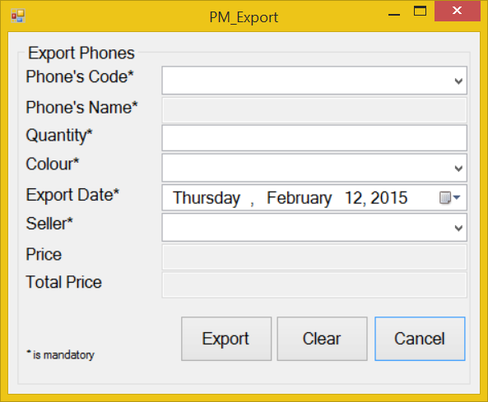
Screen | Phones Management - Export
Description | Add information about selling phone
Screen Access | Users run program by click on file Phones Management -> Export
Screen Content
Item | Type | Data | Description
Export Phone | String (50) |  | Title
Phone Code | Dropdown list – String (50) | Lookup from table PHONE.PRODUCTCODE | This field is mandatory. The code of the phone
Phone Name | Text field – String (50) | Lookup from table PHONE.PRODUCTNAME | The name of the phone. This field is disabled and read-only, user cannot edit it.
Quantity | Text field – String (50) | User input | This field is mandatory and number-only. The quantity of the phone
Colour | Dropdown list – String (50) | Lookup from table COLOR.COLOR | This field is mandatory. The colour of the phone
Export Date | Date time picker | User input | This field is mandatory. When the phone was exported?
Seller | Dropdown list – String (50) | Lookup from table STAFF.CODE | This field is mandatory. Who sold the phone?
Price | Text field – String (50) | Lookup from table PHONE.PRICE | The price of phone. This field is disabled and view-only, user cannot edit it.
Total Price | Text field – String (50) | Price*Quantity | The total price of all phone have been sold. This field is disabled and view-only, user cannot edit it.
* is mandatory | Label – String (50) |  | A note for mandatory field.
Export | Button |  | Export information about selling phone.
Clear | Button |  | Clear all the fields
Cancel | Button |  | Close Export form
Screen Actions
Action Name | Description |  | Success | Failure
Export | Export information about selling phone. |  | Show a message to ask for confirmation.  Show message: “[Quantity] phone(s) has been exported”. | If the program cannot connect to the database, display a message: “Database connection error.”  If user doesn’t choose the phone’s code, display a message:  “Phone’s code must be chosen.”  If user doesn’t enter the quantity, display a message:  “Quantity must be entered.”  If user doesn’t choose the phone’s colour, display a message:  “Colour must be chosen.”  If user doesn’t choose the export date, display a message:  “Export date must be chosen.”  If user doesn’t choose the seller, display a message:  “Seller must be chosen.”
Clear | Clear all the fields |  | Set all the field to empty and all dropdown-list to default. | Nothing
Cancel | Close Export form |  | Show a message to ask if they wanted to close the field. | Nothing

Phones Management – Edit
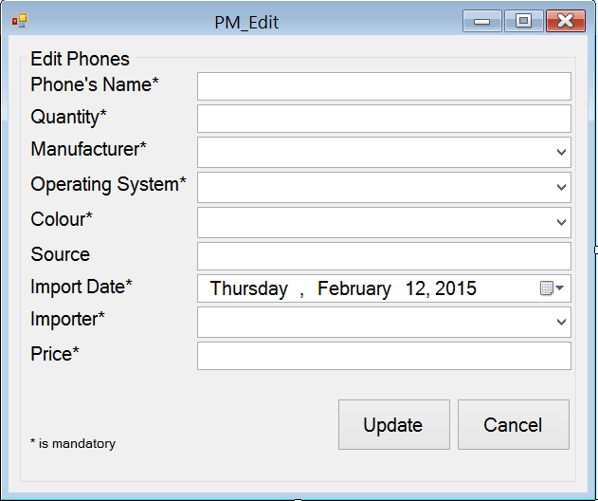
Screen | Phone Management - Edit
Description | Edit information of phone
Screen Access | Users run program by click on file Phone Management -> Edit
Screen Content
Item | Type | Data | Description
Edit Phones | String (50) |  | Title
Phone’s Name | Text field – String (50) | Lookup from table PHONE.NAME | This field is mandatory. The name of phone.
Quantity | Text field – String (50) | Lookup from table PHONE.QUANTITY | This field is mandatory and number-only. The quantity of phone
Manufacturer | Dropdown list – String (50) | Lookup from table PHONE.MANUFACTURER | This field is mandatory. The name of the manufacturer.
Operating System | Dropdown list – String (50) | Lookup from table OPERATINGSYSTEM.NAME | This field is mandatory. The name of the Operating System
Colour | Dropdown list – String (50) | Lookup from table COLOR.NAME | This field is mandatory. The colour of Phone
Source | Text field – String (50) | Lookup from table PHONE.SOURCE | Where the phone has been made.
Import Date | Date time picker | Lookup from table PHONE.IMPORTDATE | This field is mandatory. When the phone was imported.
Importer | Dropdown list – String (50) | STAFF.CODE | This field is mandatory. Who import the phone.
Price | Text field – String (50) | Table PHONE.PRICE | This field is mandatory and number-only. The price of the phone
* is mandatory | Label – String (50) |  | A note for mandatory field.
Update | Button |  | Click to update the information
Cancel | Button |  | Click to close the form
Screen Actions
Action Name | Description |  | Success | Failure
Update | Update phone information |  | Show a message to notice: “Phone’s information has been updated”. | If the program cannot connect to the database, display a message: “Database connection error.”  If user doesn’t enter the phone’s name, display a message:  “Phone’s name must be entered.”  If user doesn’t enter the quantity, display a message:  “Quantity must be entered.”  If user doesn’t choose the import date, display a message:  “Import date must be chosen.”  If user doesn’t enter the phone’s price, display a message:  “Price must be entered.”
Cancel | Close the form |  | Show a message to ask if they wanted to close the form. | Nothing

Phones Management – Order

Order – Order Phones
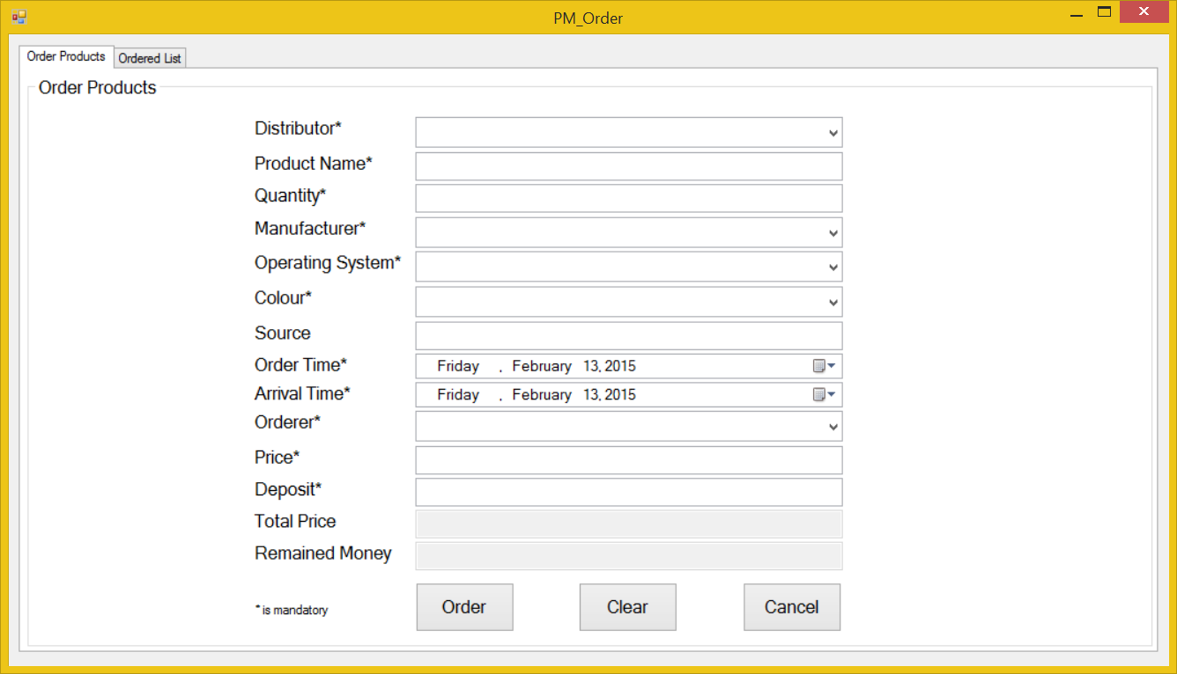
Screen | Phones Management – Order – Order Phones
Description | Order the distributor new phones in case they run out of phones
Screen Access | Users run program by click on file Phones Management -> Order -> Order Phones
Screen Content
Item | Type | Data | Description
Order Phones | Tab |  | Tab title
Order Phones | String (50) |  | Title
Distributor | Dropdown list – String (50) | Lookup from DISTRIBUTOR.NAME then input into ORDER.DISTRIBUTOR | This field is mandatory. Who distribute the phones
Phone Name | Text field – String (50) | Inserted into ORDER.PRODUCTNAME | This field is mandatory. The name of the phone
Quantity | Text field – String (50) | Inserted into ORDER.PRODUCTQUANTITY | This field is mandatory. The quantity of the phone
Manufacturer | Dropdown list – String (50) | Lookup from table MANUFACTURER.NAME then input into ORDER.MANUFACTURER | This field is mandatory. The manufacturer of the phone
Operating System | Dropdown list – String (50) | Lookup from table OPERATINGSYSTEM.NAME then input into ORDER.OPERATINGSYSTEM | This field is mandatory. The operating system of the phone
Colour | Dropdown list – String (50) | Lookup from table COLOR.NAME then input into ORDER.PRODUCTCOLOR | This field is mandatory. The colour of the phone
Source | Text field – String (50) | Inserted into ORDER.SOURCE | Where the phone has been made
Order Time | Date time picker | Inserted into ORDER.ORDERTIME | This field is mandatory. When did they ordered them
Arrival Time | Date time picker | Inserted into ORDER.ARRIVALTIME | This field is mandatory. When will the phone arrive
Orderer | Dropdown list – String (50) | Inserted into ORDER.ORDERER | This field is mandatory. The staff member who order this phone.
Price | Text field – String (50) | Inserted into ORDER.PRICE | This field is mandatory. The price of the phone
Deposit | Text field – String (50) |  | This field is mandatory. The amount of money which orderer leaved as a deposit.
Total Price | Text field – String (50) | Price*Quantity. | This field is read-only, user cannot edit it. The total price of all the phones has been ordered
Remained money | Text field – String (50) | Total price - Deposit | This field is read-only. Display amount of remained money after the ordered pay a deposit.
* is mandatory | Label – String (50) |  | A note for mandatory field.
Order | Button |  | Add to database
Clear | Button |  | Clear all the fields
Cancel | Button |  | Close the form
Screen Actions
Action Name | Description |  | Success | Failure
Order | Add to database |  | Show a message to notice: “An order has been added”. | If the program cannot connect to the database, display a message: “Database connection error.”  If user doesn’t choose the distributor, display a message:  “Distributor must be chosen.”  If user doesn’t enter the phone’s name, display a message:  “Phone’s name must be entered.”  If user doesn’t enter the quantity, display a message:  “Quantity must be entered.”  If user doesn’t choose the manufacturer’s name, display a message:  “Manufacturer must be chosen.”  If user doesn’t choose the operating system, display a message:  “Operating system must be chosen.”  If user doesn’t choose the phone’s colour, display a message:  “Colour must be chosen.”  If user doesn’t choose the order time, display a message:  “Order time must be chosen.”  If user doesn’t choose the arrival time, display a message:  “Arrival time must be chosen.”  If user doesn’t enter the orderer, display a message:  “Orderer must be entered.”  If user doesn’t enter the phone’s price, display a message:  “Price must be entered.”
Clear | Clear all the fields |  | Set all the field to empty and all dropdown-list to default. | Nothing.
Cancel | Close the form |  | Show a message to ask if they wanted to close the form. | Nothing.

Order – Ordered List
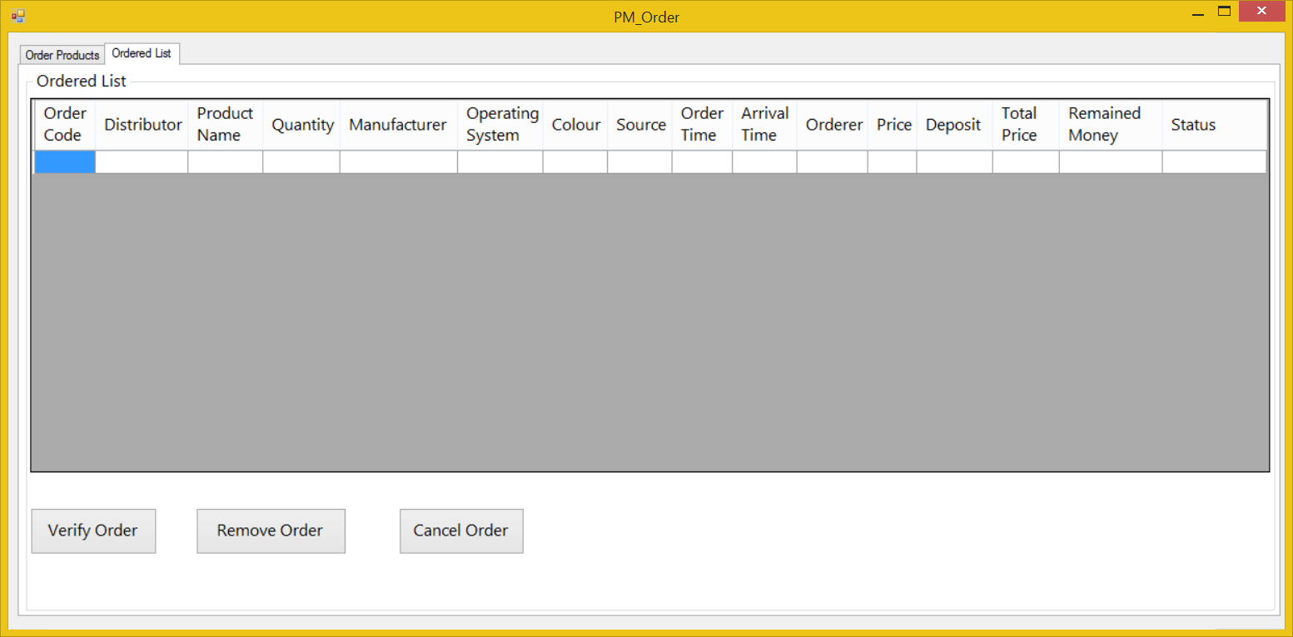
Screen | Phones Management – Order – Ordered List
Description |  | Display the orders has been added to the database.
Screen Access |  | Users run program then click on Phones Management -> Order -> Ordered List
Screen Content
Item |  | Type | Data | Description
Ordered List |  | Tab |  | Tab title
Ordered List |  | String (50) |  | Title
Data grid view |  | Data grid view | Lookup all fields from ORDER table. | - Display all fields about the ordered list when the form loaded: Distributor, product name, quantity, manufacturer, operating system, colour, source, order time, arrival time, ordered, price, deposit, total price, remained money, status.  - This table is read-only, user cannot edit it.
Verify Order |  | Button |  | User choose an order from the table above and click on this button to verify the order has been arrived.
Remove Order |  | Button |  | User choose an order from the table above and click on this button to remove the arrival order.
Cancel Order |  | Button |  | User choose an order from the table above and click on this button to cancel the pending order.
Screen Actions
Action Name |  | Description |  | Success | Failure
Verify Order |  | Verify an order |  | Show a message to confirm. | If user doesn’t choose any orders, display a message: “Please choose an order to verify”.
Remove Order |  | Remove an order |  | Show a message to confirm. | If user doesn’t choose any orders, display a message: “Please choose an order to remove”.
Cancel Order |  | Cancel an order |  | Show a message to confirm. | If user doesn’t choose any orders, display a message: “Please choose an order to cancel”.

Assets Management:
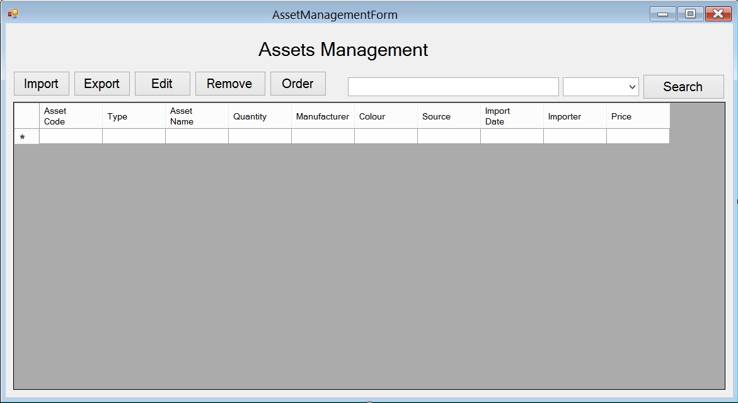
Screen | Assets Management
Description |  | Show information of assets, user can import new assets, export (sell) them, edit their information, remove them. In case they run out of some assets, they could order some more.
Screen Access |  | Users run program then click on Assets Management button
Screen Content
Item |  | Type | Data | Description
Data grid view |  | Data grid view | Lookup all fields from ASSET table. | - Display all fields about the asset when the form loaded: asset code, type, asset name, quantity, manufacturer, colour, source, import date, importer, price  - This table is read-only, user cannot edit it.
Import |  | Button |  | User click on it to open “Import Assets” dialog and add new assets.
Export |  | Button |  | User click on it to open “Export Assets” dialog and add information of selling asset into database.
Edit |  | Button |  | User click on it to open “Edit Assets” and edit information of asset
Remove |  | Button |  | User click on it to remove the chosen asset in data grid view in case they stop selling them.
Order |  | Button |  | Open “Order Assets” dialog. When the store run out of some phones or some new assets that they don’t have, they could order their distributor to get them.
Search |  | Button |  | Search assets by name, manufacturer, price
Textbox |  | Text field – String (50) |  | Enter the keyword that user want to search.
Combo box |  | Drop down list |  | User choose which field they want to search by: name, manufacturer and price.
Screen Actions
Action Name |  | Description |  | Success | Failure
Import |  | Add information of new assets. |  | “Import Assets” dialog opened. | If there’re any coding exceptions when running this function, a message will be appeared: “Cannot open ‘Import Assets’ dialog”.
Export |  | Add information of selling assets. |  | “Export Assets” dialog opened. | If there’re any coding exceptions when running this function, a message will be appeared: “Cannot open ‘Export Assets’ dialog”.
Edit |  | Edit information of assets. |  | “Edit Assets” dialog opened. | Display a message “Database connection error”.  If there’re any coding exceptions when running this function, a message will be appeared: “Cannot open ‘Edit Assets’ dialog”.
Remove |  | Remove assets from database. |  | Data grid view’s item removed. | Nothing.
Order |  | Make an order for new assets. |  | “Order Assets” dialog opened. | If there’re any coding exceptions when running this function, a message will be appeared: “Cannot open ‘Order Assets’ dialog”.
Search |  | Find a asset in the table below. |  | Return the result of searching process. | If there aren’t anything match with the input keyword, display a message: “Not found”.

Assets Management – Import
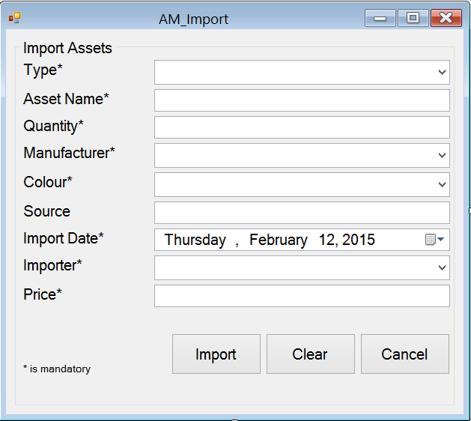
Screen | Assets Management - Import
Description | Add new assets into data base
Screen Access | Users run program by click on file Assets Management -> Import
Screen Content
Item | Type | Data | Description
Import Phone | String (50) | Hard code | A title label.
Type | Dropdown list – String (50) | Lookup from table ASSET.TYPE | This field is mandatory. Type of assets.
Asset Name | Text field – String (50) | Inserted into ASSET.NAME | This field is mandatory. The name of asset.
Quantity | Text field – String (50) | Inserted into ASSET.QUANTITY | This field is mandatory and number-only. The quantity of asset
Manufacturer | Dropdown list – String (50) | Lookup from table MANUFACTURER.NAME then input into ASSET.MANUFACTURER | This field is mandatory. The name of the manufacturer.
Colour | Dropdown list – String (50) | Lookup from table COLOR.NAME then input into ASSET.COLOR | This field is mandatory. The colour of asset
Source | Text field – String (50) | Inserted into ASSET.SOURCE | Where the asset has been made.
Import Date | Date time picker | Inserted into ASSET.IMPORTDATE | This field is mandatory. When the asset was imported.
Importer | Dropdown list – String (50) | Lookup from table STAFF.NAME then input into ASSET.STAFF | This field is mandatory. Who import the asset
Price | Text field – String (50) | Inserted into ASSET.PRICE | This field is mandatory and number-only. The price of the asset
Import | Button |  | Import new asset
Clear | Button |  | Clear all the fields
Cancel | Button |  | Cancel importing action
Screen Actions
Action Name | Description |  | Success | Failure
Import | Import new asset |  | Show a message to ask for confirmation.  Show message: “[Quantity] asset (s) has been imported”. | If the program cannot connect to the database, display a message: “Database connection error.”  If user doesn’t choose the type, display a message:  “Type must be chosen.”  If user doesn’t enter the Asset’s name, display a message: “Asset’s name must be entered.”  If user doesn’t enter the quantity, display a message: “Quantity must be entered.”  If user doesn’t choose the manufacturer, display a message: “Manufacturer must be chosen.”  If user doesn’t choose the Asset’s colour, display a message: “Colour must be chosen.”  If user doesn’t choose the import date, display a message: “Import date must be chosen.”  If user doesn’t choose the importer, display a message: “Importer must be chosen.”  If user doesn’t enter the Asset’s price, display a message: “Price must be entered.”
Clear | Clear all the fields |  | Set all the field to empty and all dropdown-list to default. | Nothing.
Cancel | Cancel importing action |  | Show a message to ask if they wanted to close the form. | Nothing.

Assets Management – Export
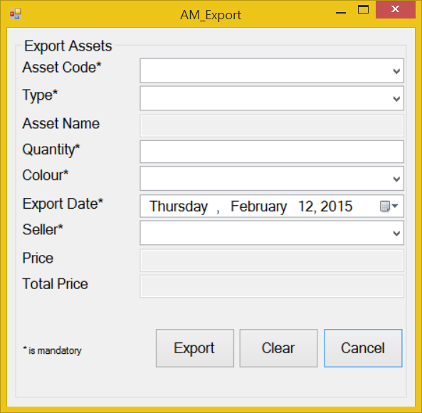
Screen | Assets Management - Export
Description | Add information about selling asset
Screen Access | Users run program by click on file Assets Management -> Export
Screen Content
Item | Type | Data | Description
Export Asset | String (50) |  | Title
Asset Code | Dropdown list – String (50) | Lookup from table PHONE.PRODUCTCODE | This field is mandatory. The code of the phone
Type | Dropdown list – String (50) | Lookup from table ASSET.TYPE | This field is mandatory. Type of asset
Asset Name | Text field – String (50) | Lookup from table ASSET.PRODUCTNAME | The name of the asset. This field is disabled and view-only, user cannot edit it.
Quantity | Text field – String (50) | User input. Inserted into ASSET.QUANTITY | This field is mandatory and number-only. The quantity of the asset
Colour | Dropdown list – String (50) | Lookup from table COLOR.NAME | This field is mandatory. The colour of the asset
Export Date | Date time picker | User input | This field is mandatory. When the asset was exported?
Seller | Dropdown list – String (50) | Lookup from table STAFF.CODE | This field is mandatory. Who sold the asset?
Price | Text field – String (50) | Lookup from table ASSET.PRICE | The price of asset. This field is disabled and view-only, user cannot edit it.
Total Price | Text field – String (50) | Price*Quantity | The total price of all asset have been sold. This field is disabled and view-only, user cannot edit it.
Export | Button |  | Export information about selling asset.
Clear | Button |  | Clear all the fields
Cancel | Button |  | Close Export form
Screen Actions
Action Name | Description |  | Success | Failure
Export | Export information about selling asset. |  | Show a message to ask for confirmation.  Show message: “[Quantity] asset (s) has been exported”. | If the program cannot connect to the database, display a message: “Database connection error.”  If user doesn’t choose the Asset’s code, display a message: “Asset’s code must be chosen.”  If user doesn’t choose the type, display a message: “Type must be chosen.”  If user doesn’t enter the quantity, display a message: “Quantity must be entered.”  If user doesn’t choose the Asset’s colour, display a message: “Colour must be chosen.”  If user doesn’t choose the export date, display a message: “Export date must be chosen.”  If user doesn’t choose the seller, display a message: “Seller must be chosen.”
Clear | Clear all the fields |  | Set all the field to empty and all dropdown-list to default. | Nothing
Cancel | Close Export form |  | Show a message to ask if they wanted to close the field. | Nothing

Assets Management – Edit
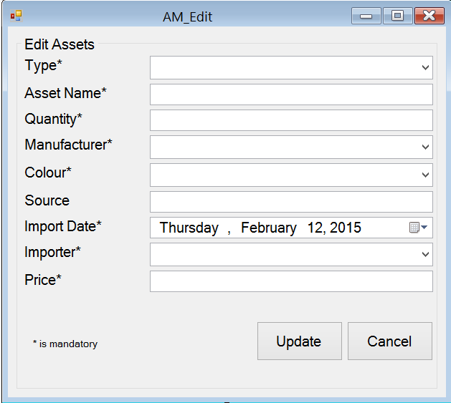
Screen | Asset Management - Edit
Description | Edit information of asset
Screen Access | Users run program by click on file Asset Management -> Edit
Screen Content
Item | Type | Data | Description
Edit Assets | String (50) |  | Title
Type | Dropdown list – String (50) | Lookup from table ASSET.TYPE | This field is mandatory. The type of asset.
Asset Name | Text field – String (50) | Lookup from table ASSET.NAME | This field is mandatory. The name of asset.
Quantity | Text field – String (50) | Lookup from table ASSET.QUANTITY | This field is mandatory and number-only. The quantity of asset
Manufacturer | Dropdown list – String (50) | Lookup from table ASSET .MANUFACTURER | This field is mandatory. The name of the manufacturer.
Colour | Dropdown list – String (50) | Lookup from table COLOR.NAME | This field is mandatory. The colour of asset
Source | Text field – String (50) | Lookup from table ASSET.SOURCE | Where the asset has been made.
Import Date | Date time picker | Lookup from table ASSET.IMPORTDATE | This field is mandatory. When the asset was imported.
Importer | Dropdown list – String (50) | STAFF.CODE | This field is mandatory. Who import the asset
Price | Text field – String (50) | Table ASSET.PRICE | This field is mandatory and number-only. The price of the asset
Update | Button |  | Click to update the information
Cancel | Button |  | Click to close the form
Screen Actions
Action Name | Description |  | Success | Failure
Update | Update asset information |  | Show a message to notice: “Asset’s information has been updated”. | If the program cannot connect to the database, display a message: “Database connection error.”  If user doesn’t choose the Type, display a message: “Type must be chosen.”  If user doesn’t enter the Asset’s name, display a message: “Asset name must be entered.”  If user doesn’t enter the quantity, display a message: “Quantity must be entered.”  If user doesn’t choose the import date, display a message: “Import date must be chosen.”  If user doesn’t enter the Asset’s price, display a message: “Price must be entered.”
Cancel | Close the form |  | Show a message to ask if they wanted to close the form. | Nothing

Assets Management – Order

Order – Order Assets
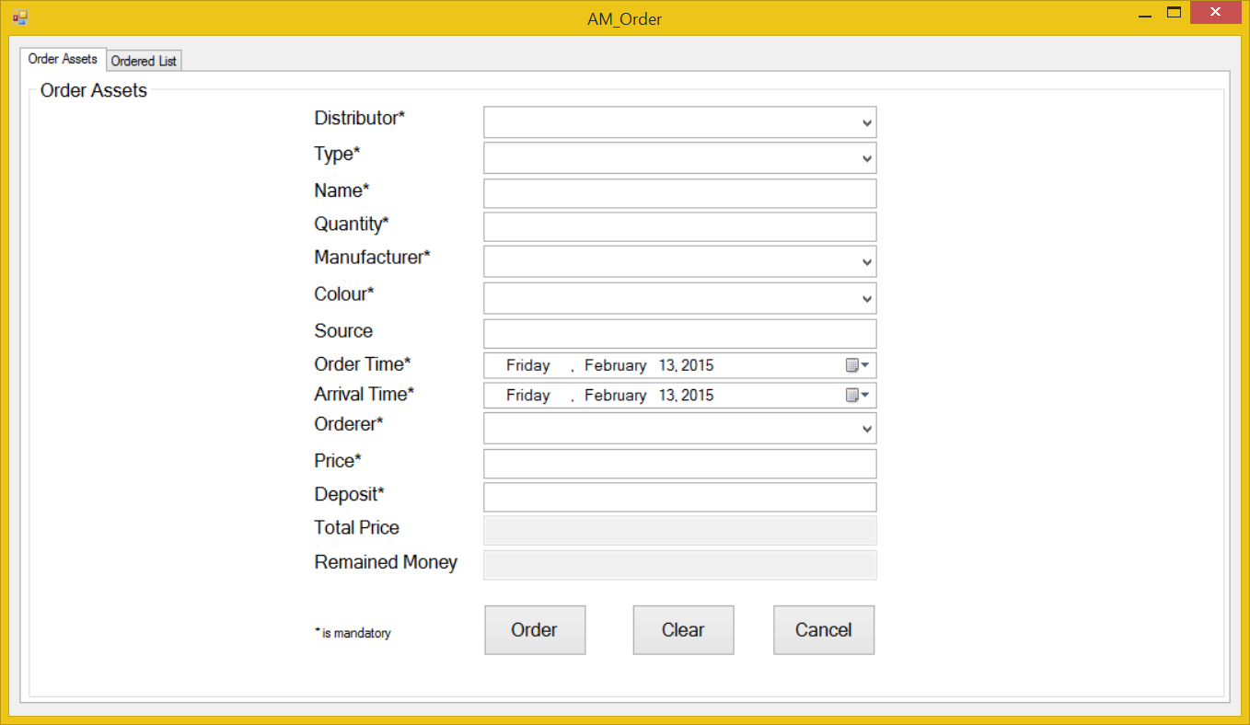
Screen | Assets Management – Order – Order Assets
Description | Order the distributor new Assets in case they run out of Assets
Screen Access | Users run program by click on file Assets Management -> Order -> Order Assets
Screen Content
Item | Type | Data | Description
Order Assets | Tab |  | Tab title
Order Assets | String (50) |  | Title
Distributor | Dropdown list – String (50) | Lookup from DISTRIBUTOR.NAME then input into ORDER.DISTRIBUTOR | This field is mandatory. Who distribute the assets
Type | Dropdown list – String (50) | Lookup from table ASSET.TYPE | This field is mandatory. The type of asset.
Asset Name | Text field – String (50) | Inserted into ORDER.PRODUCTNAME | This field is mandatory. The name of the assets
Quantity | Text field – String (50) | Inserted into ORDER.PRODUCTQUANTITY | This field is mandatory. The quantity of the assets
Manufacturer | Dropdown list – String (50) | Lookup from table MANUFACTURER.NAME then input into ORDER.MANUFACTURER | This field is mandatory. The manufacturer of the assets
Colour | Dropdown list – String (50) | Lookup from table COLOR.NAME then input into ORDER.PRODUCTCOLOR | This field is mandatory. The colour of the assets
Source | Text field – String (50) | Inserted into ORDER.SOURCE | Where the phone has been made
Order Time | Date time picker | Inserted into ORDER.ORDERTIME | This field is mandatory. When did they ordered them
Arrival Time | Date time picker | Inserted into ORDER.ARRIVALTIME | This field is mandatory. When will the assets arrive
Orderer | Dropdown list – String (50) | Inserted into ORDER.ORDERER | This field is mandatory. Who ordered this assets
Price | Text field – String (50) | Inserted into ORDER.PRICE | This field is mandatory. The price of the assets
Deposit | Text field – String (50) |  | This field is mandatory. The amount of money which orderer leaved as a deposit.
Total Price | Text field – String (50) | Price*Quantity. | This field is read-only, user cannot edit it. The total price of all the phones has been ordered
Remained money | Text field – String (50) | Total price - Deposit | This field is read-only. Display amount of remained money after the ordered pay a deposit.
Order | Button |  | Add to database
Clear | Button |  | Clear all the fields
Cancel | Button |  | Close the form
Screen Actions
Action Name | Description |  | Success | Failure
Order | Add to database |  | Show a message to notice: “An order has been added”. | If the program cannot connect to the database, display a message: “Database connection error.”  If user doesn’t choose the distributor, display a message: “Distributor must be chosen.”  If user doesn’t choose the type, display a message: “Type must be chosen.”  If user doesn’t enter the asset’s name, display a message: “Asset name must be entered.”  If user doesn’t enter the quantity, display a message: “Quantity must be entered.”  If user doesn’t enter the manufacturer, display a message: “Manufacturer must be chosen.”  If user doesn’t choose the colour, display a message: “Colour must be chosen.”  If user doesn’t choose the order time, display a message: “Order time must be chosen.”  If user doesn’t choose the arrival time, display a message: “Arrival time must be chosen.”  If user doesn’t enter the orderer, display a message: “Orderer must be entered.”  If user doesn’t enter the price, display a message: “Price must be entered.”
Clear | Clear all the fields |  | Set all the field to empty and all dropdown-list to default. | Nothing.
Cancel | Close the form |  | Show a message to ask if they wanted to close the form. | Nothing.

Order – Ordered List
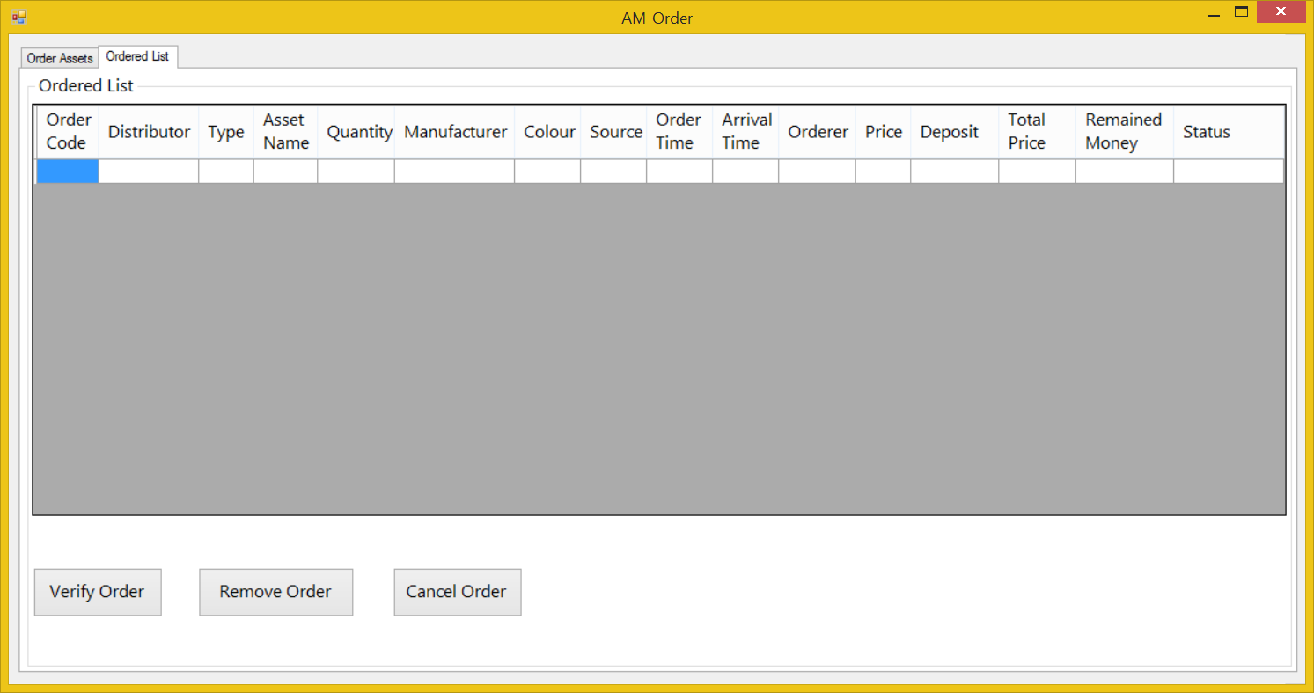
Screen | Assets Management – Order – Ordered List
Description |  | Display the orders has been added to the database.
Screen Access |  | Users run program then click on Assets Management -> Order -> Ordered List
Screen Content
Item |  | Type | Data | Description
Ordered List |  | Tab |  | Tab title
Ordered List |  | String (50) |  | Title
Data grid view |  | Data grid view | Lookup all fields from ORDER table. | - Display all fields about the ordered list when the form loaded: Distributor, type, asset name, quantity, manufacturer, colour, source, order time, arrival time, ordered, price, deposit, total price, remained money, status.  - This table is read-only, user cannot edit it.
Verify Order |  | Button |  | User choose an order from the table above and click on this button to verify the order has been arrived.
Remove Order |  | Button |  | User choose an order from the table above and click on this button to remove the arrival order.
Cancel Order |  | Button |  | User choose an order from the table above and click on this button to cancel the pending order.
Screen Actions
Action Name |  | Description |  | Success | Failure
Verify Order |  | Verify an order |  | Show a message to confirm. | If user doesn’t choose any orders, display a message: “Please choose an order to verify”.
Remove Order |  | Remove an order |  | Show a message to confirm. | If user doesn’t choose any orders, display a message: “Please choose an order to remove”.
Cancel Order |  | Cancel an order |  | Show a message to confirm. | If user doesn’t choose any orders, display a message: “Please choose an order to cancel”.

Staff Management
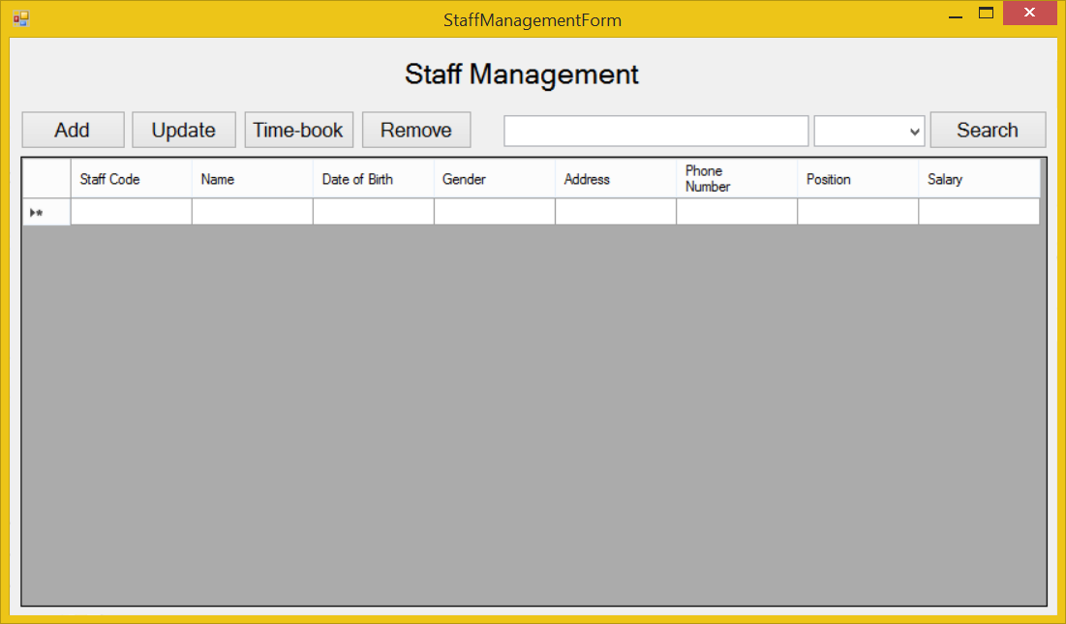
Screen | Staff Management
Description |  | Display a screen where user can manage their staff.
Screen Access |  | Users run program then click on Staff Management button.
Screen Content
Item |  | Type | Data | Description
Data grid view |  | Data grid view | Lookup all fields from STAFF table. | - Display all fields about the staff when the form loaded: staff code, name, date of birth, gender, address, phone number, position and salary.  - This table is read-only, user cannot edit it.
Add |  | Button |  | Open “Add Staff” dialog when user click it.
Update |  | Button |  | Open “Update Staff” dialog when user choose an item from data grid view and click this button.
Time-book |  | Button |  | Open “Time-book” dialog when user click it.
Remove |  | Button |  | Remove a staff when user choose an item from data grid view and click this button.
Search |  | Button |  | User click on it to search
Textbox |  | Text field – String (50) |  | User type their keyword to search
Combo box |  | Drop down list |  | Filter searching result by: Name
Screen Actions
Action Name |  | Description |  | Success | Failure
Add |  | Open “Add Staff” dialog |  | “Add Staff” dialog opened | If there’re any coding exceptions when running this function, a message will be appeared: “Cannot open ‘Add Staff’ dialog”.
Update |  | Open “Update Staff” dialog |  | “Update Staff” dialog opened | If there’re any coding exceptions when running this function, a message will be appeared: “Cannot open ‘Update Staff’ dialog”.
Time-book |  | Open “Time-book” dialog |  | “Time-book” dialog opened | If there’re any coding exceptions when running this function, a message will be appeared: “Cannot open ‘Time-book’ dialog”.
Remove |  | Remove a staff |  | Data grid view’s item removed. | Nothing.
Search |  | Find a product in the table below. |  | Return the result of searching process | If there aren’t anything match with the input keyword, display a message: “Not found”.

Staff Management – Add
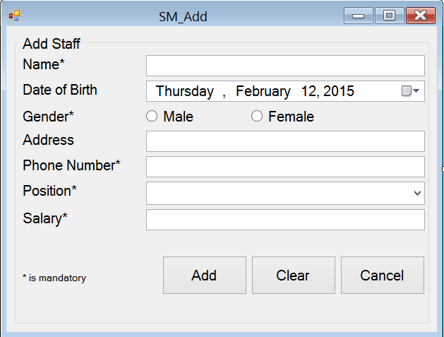
Screen | Staff Management – Add Staff
Description | Allow Administrator and Managers Account to add new staff members.
Screen Access | Users run program by click on file Staff Management -> Add
Screen Content
Item | Type | Data | Description
Add Staff | String (50) |  | Name of the form
Name | Text field – String (50) | Inserted into STAFF.NAME | This field is mandatory.  Name of staff member.
Date of birth | Date time picker | Inserted into STAFF.DOB | User pick the date from a date time picker
Gender - Male | Radio button | Inserted into STAFF.GENDER | This field is mandatory.  Gender of staff member (male)
Gender - female | Radio button | Inserted into STAFF.GENDER | This field is mandatory.  Gender of staff member (female)
Address | Text field – String (50) | Inserted into STAFF.ADDRESS | Address of staff member. This field is optional.
Phone number | Text field – String (50) | Inserted into STAFF.PHONENUMBER | This field is mandatory and number only. Managers need staff member’s phone number to contact.
Position | Dropdown list – String (50) | Inserted into STAFF.POSITION | This field is mandatory. Choose from the available position in the dropdown list.
Salary | Text field – String (50) | Inserted into STAFF.SALARY | This field is mandatory and number only.
Add | Button |  | Add data into database
Clear | Button |  | Clear all inserted data
Cancel | Button |  | Cancel “Add Staff”.
Screen Actions
Action Name | Description |  | Success | Failure
Add | Inserted data will be saved into the DB. |  | Display a message “A staff member has been added”.  Back to the “Staff Management” screen with new record on the table below (default list with all data).  When go back to the list from “Staff Management” screen, the new record will be focused on. | If the program cannot connect to the database, display a message: “Database connection error.”  If user doesn’t enter the Name, display a message:  “Name must be entered.”  If user doesn’t choose the Gender, display a message: “Gender must be chosen.”  If user doesn’t enter the phone number, display a message: “Phone number must be entered.”  If user doesn’t enter the position, display a message: “Position must be chosen.”  If user doesn’t enter the salary, display a message: “Salary number must be entered.”
Clear | Clear inserted data. |  | All field cleared. | Nothing.
Cancel | Close “Add Staff” dialog. |  | “Add Staff” dialog closed. | Nothing.

Staff Management – Update
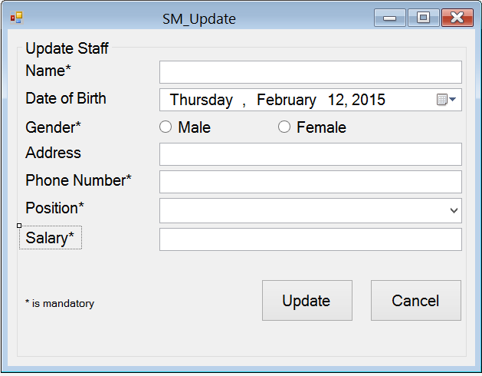
Screen | Staff Management – Update Staff
Description | Allow Administrator and Managers Account to update existing staff members.
Screen Access | Users run program by click on file Staff Management -> Update
Screen Content
Item | Type | Data | Description
Update Staff | String (50) |  | Name of the form
Name | Text field – String (50) | Look up from STAFF.NAME | This field is mandatory.  Name of staff member.
Date of birth | Date time picker | Look up from STAFF.DOB | User pick the date from a date time picker
Gender - Male | Radio button | Look up from STAFF.GENDER | This field is mandatory.  Gender of staff member (male)
Gender - female | Radio button | Look up from STAFF.GENDER | This field is mandatory.  Gender of staff member (female)
Address | Text field – String (50) | Look up from STAFF.ADDRESS | Address of staff member. This field is optional.
Phone number | Text field – String (50) | Look up from STAFF.PHONENUMBER | This field is mandatory and number only. Managers need staff member’s phone number to contact.
Position | Dropdown list – String (50) | Look up from STAFF.POSITION | This field is mandatory. Choose from the available position in the dropdown list.
Salary | Text field – String (50) | Look up from STAFF.SALARY | This field is mandatory and number only.
Add | Button |  | Add data into database
Cancel | Button |  | Cancel “Add Staff”.
Screen Actions
Action Name | Description |  | Success | Failure
Update | Inserted data will be saved into the DB. |  | Display a message “A staff member has been updated”.  Back to the “Staff Management” screen with new record on the table below (default list with all data).  When go back to the list from “Staff Management” screen, the new record will be focused on. | If the program cannot connect to the database, display a message: “Database connection error.”  If user doesn’t enter the Name, display a message:  “Name must be entered.”  If user doesn’t choose the Gender, display a message: “Gender must be chosen.”  If user doesn’t enter the phone number, display a message: “Phone number must be entered.”  If user doesn’t enter the position, display a message: “Position must be chosen.”  If user doesn’t enter the salary, display a message: “Salary number must be entered.”
Cancel | Close “Update Staff” dialog. |  | “Update Staff” dialog closed. | Nothing.

Staff Management – Time-book
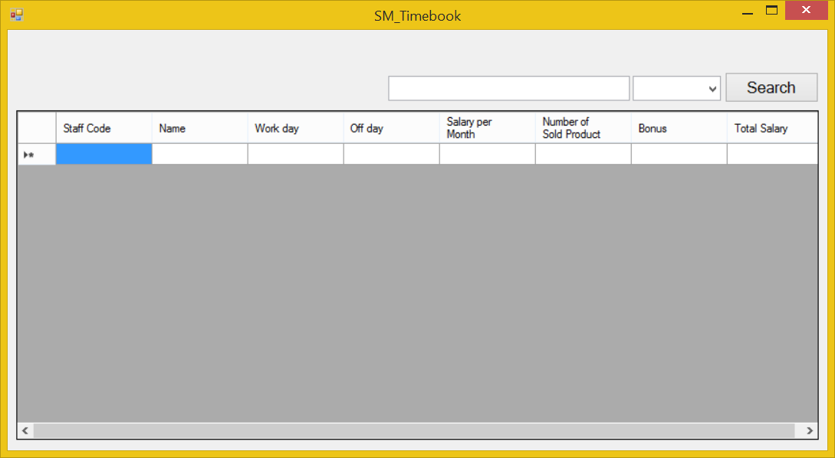
Screen | Staff Management – Time-book.
Description |  | Display a screen where user can manage staff member’s jobs.
Screen Access |  | Users run program then click on Staff Management -> Time-book
Screen Content
Item |  | Type | Data | Description
Data grid view |  | Data grid view | Lookup all fields from TIMEBOOK table. | - Display all fields about the staff’s time-book when the form loaded: staff code, name, work day, off day, salary per month, number of product sold, bonus, total salary.  - This table is read-only, user cannot edit it.
Search |  | Button |  | User click on it to search
Textbox |  | Text field – String (50) |  | User type their keyword to search
Combo box |  | Drop down list |  | Filter searching result by: Name
Screen Actions
Action Name |  | Description |  | Success | Failure
Search |  | Find a product in the table below. |  | Return the result of searching process | If there aren’t anything match with the input keyword, display a message: “Not found”.

Report

Report – Total Statics
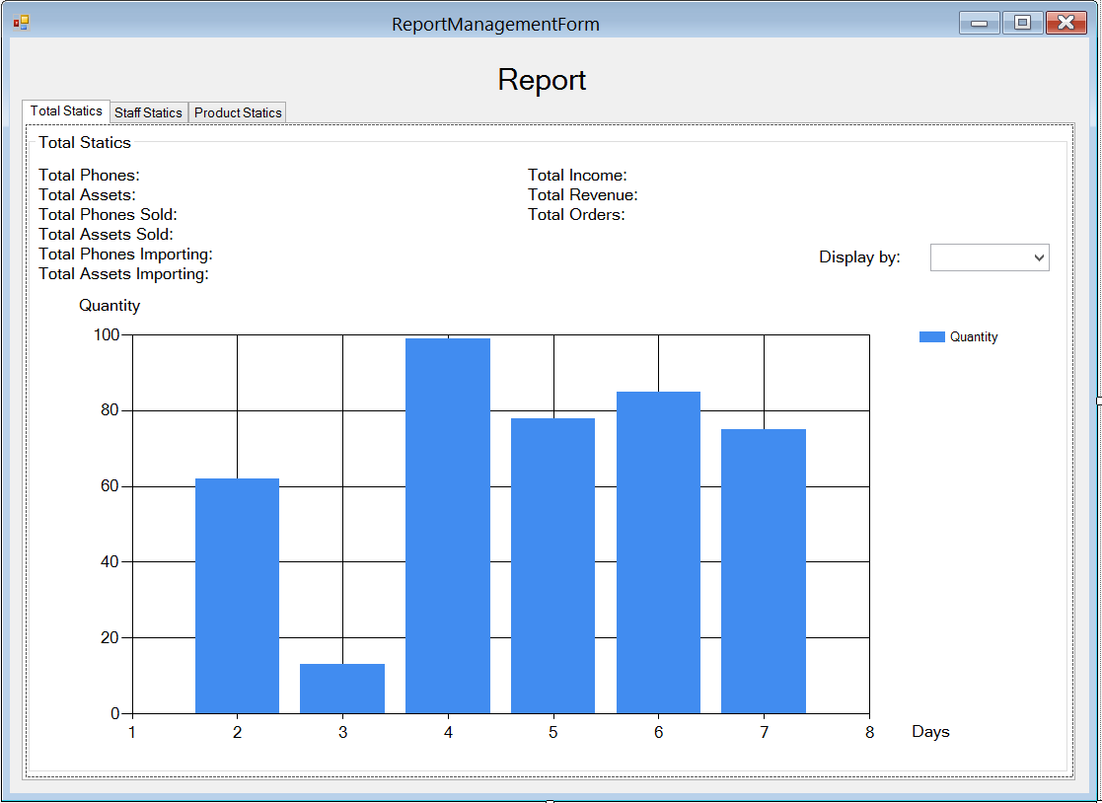
Screen | Report Management - Total statics
Description |  | Allow Administrator and Managers view their total statics in a month.
Screen Access |  | Users run program then click on Report button
Screen Content
Item |  | Type | Data | Description
Tab Total Statics |  | Tab |  | Titles
Total Phone |  | Label – String (50) | Count all available phones in table PHONE | Display total available phones in DB.
Total Assets |  | Label – String (50) | Count all available phones in table ASSET | Display total available assets in DB.
Total Phone Sold |  | Label – String (50) |  | Display total phones sold.
Total Assets Sold |  | Label – String (50) |  | Display total assets sold.
Total Phone Importing |  | Label – String (50) | Count all available phones which are importing in table ORDER | Display phones which are importing.
Total Assets Importing |  | Label – String (50) | Count all available assets which are importing in table ORDER | Display assets which are importing.
Total Income |  | Label – String (50) |  | Display total income.
Total Revenue |  | Label – String (50) |  | Display Total Revenue
Total Orders |  | Label – String (50) |  | Display Total Orders
Display by |  | Drop down list – String (50) |  | Display information in chart below by total phones, assets; total phones, assets sold; total importing phones, assets; total income, revenue, orders.
Chart |  | Chart |  | Display data when user choose an item from dropdown list.  X-axis is days of a month.  Y-axis is quantity.  The chart in the image above is just an example.
Screen Actions
Action Name |  | Description |  | Success | Failure
Choose |  | Choose an item from combo box “Display by:” |  | Display information to the chart below. | If the program cannot connect to the database, display a message: “Database connection error.”

Report – Staff Statics
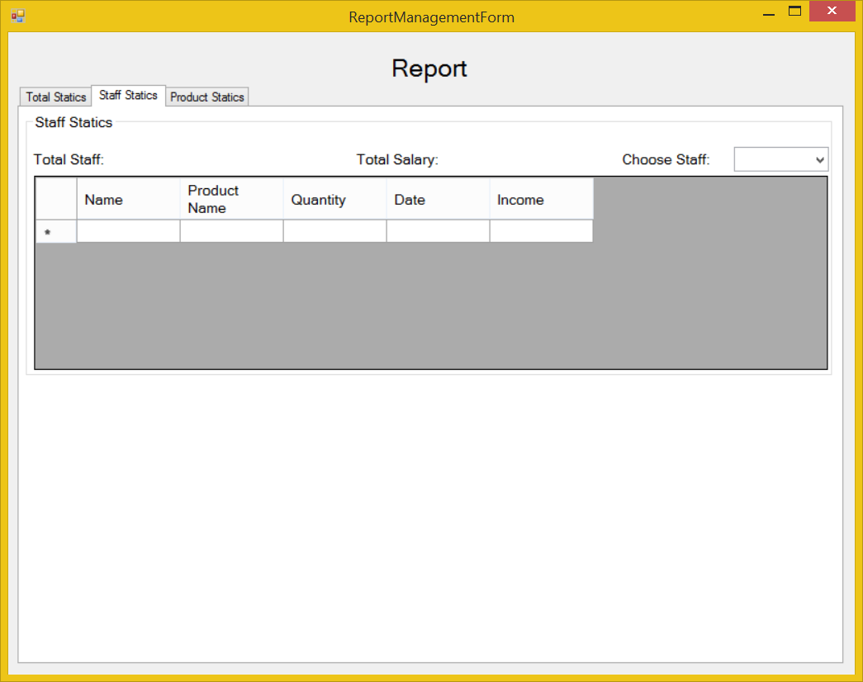
Screen | Report – Staff Statics
Description | Allow Administrator and Managers view their statics about staff members.
Screen Access | Users run program by click on file Report -> Staff Statics
Screen Content
Item | Type | Data | Description
Staff Statics | Tab |  | Tab name
Staff Statics | Label – String (50) |  | Name of the staff statics group
Total Staff | Label – String (50) | Look up from STAFF, count all of available staff members in DB except Administrator. | Display total available staff members in DB.
Total Salary | Label – String (50) |  | Display total available salary of all staff members in DB.
Choose Staff | Combo box | Look up from STAFF.STAFFCODE | Choose a staff code from the dropdown list to view information at a specific staff member in data grid view below.
Data grid view | Data grid view |  | - Display all fields about the staff when the staff code is chose: Name, product name, quantity, date, income.  - This table is read-only, user cannot edit it.
Screen Actions
Action Name | Description |  | Success | Failure
Choose. | Choose an item from combo box “Choose Staff:” |  | Display information to the data grid view below. | If the program cannot connect to the database, display a message: “Database connection error.”

Report – Product Statics
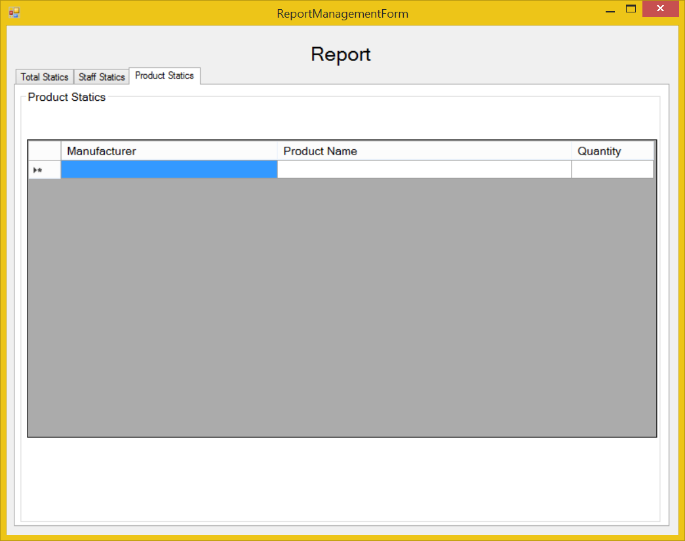
Screen | Report – Products Statics
Description | Allow Administrator and Managers view their statics about products.
Screen Access | Users run program by click on file Report -> Product Statics
Screen Content
Item | Type | Data | Description
Products Statics | Tab |  | Tab name
Products Statics | Label – String (50) |  | Name of the Products statics group
Data grid view | Data grid view | Look up from PHONE.MANUFACTURER and ASSET.MANUFACTURER join with PHONE.NAME and ASSET.NAME then count all them. | - Display all fields about the Products when the form loaded: Manufacturer, product name, quantity.  - This table is read-only, user cannot edit it.
Screen Actions
Action Name | Description |  | Success | Failure

NON-FUNCTIONAL REQUIREMENTS AND OTHERS

Performance
No. | Requirement
1. | Allow at least 10 users access at the same time
2 | Can run on computer with 512MB of RAM or higher, 1.7 GHz of CPU or higher, Windows XP 32bit or higher
3 | Used maximum 256MB of disk space (not include database)

Scalability
No. | Requirement
1. | Allow admin to limit the maximum of user access the system at the same time
2 | Allow developer to add more type of user with the different authority
3 | Allow admin to create more user account

Security
No. | Requirement
1. | Protect customer information
2. | Ensure the integrity, security of data
3 | Decentralize the user
4 | Protect internal information
5 | The system’s back-end databases shall be encrypted.

Network
No | Requirement
1 | Allow the manager to manage the store from home using the internet

Backup and restore
No | Requirement
1 | The system can synchronize automatically every day
2 | In case the system get error, it can restore, back to the status before getting error

Reliability
No | Requirement
1 | Only administrator can change product information
2 | Every changed of price have to be confirmed by the manager
3 | The system shall provide storage of all databases on redundant computers with automatic switchover.

Interfaces
No. | Requirement
1. | Font style is the same with http://www.customer.com.sg/default.aspx
2 | The GUI must have no more than 10 buttons each form
3 | The menu must have no more than 5 submenus
4 | Use the fresh color like the yellow green, blue, green, yellow .etc.

User manual and help
No | Requirement
1 | The software shall show the Use guide in the first running
2 | The software shall have a Help menu to show the Use guide in case users don’t know how to use or what is the purpose of the function

Extensibility
No. | Requirement
1. | Can add more table record without conflictions with the older
2. | Allow the developer to add more functions without conflictions
3 | The software can provide data to other application on other platform

APPENDIX

